
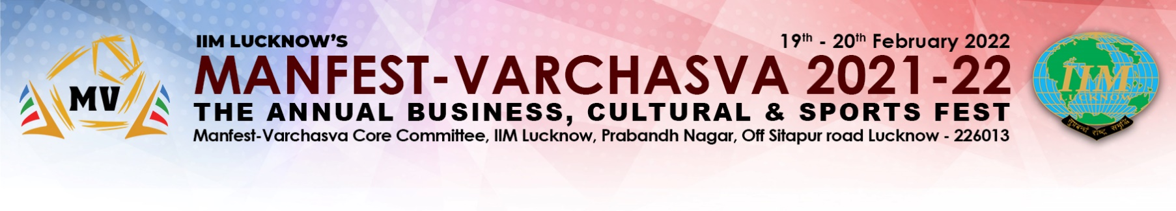
To, Date: 14-02-2022

Prof. Prem Prakash Dewani

Chairman, Students Affairs and Placements
Indian Institute of Management Lucknow

Subject: Approval for constitution of Spot Purchase Committee for Manfest-Varchasva 2022

Dear Sir,

We request your approval in forming the spot purchase committee to decide on the vendors for the following items.

Component | Amount(INR)
Banners, Flexes, Posters, Certificates and Flyers | 130000
Light and Sound, Tent and Generator | 450000
Informal events | 130000

The member of Spot Purchase Committee would be

Department | Name with Contact number
One member from Students Affairs Office | Sanjay S Degloorkar (9839096034)
One member from Student Council | Divay Chugh (9599616818)
One member from Manfest-Varchasva Core Committee | Kamal Sharma (9928936149)

Sincere Regards,

Kamal Sharma
PGP37410
(9928936149)

